Success Factors IAS Integration

The process of migrating to the Identity Authentication Service requires us to perform tasks in SAP SuccessFactors Admin Center, the Identity Provisioning service Administration Console, and in the Identity Authentication service Administration Console. All the configuration steps are as per the latest SAP guide linked below:
https://help.sap.com/docs/SAP_SUCCESSFACTORS_PLATFORM/568fdf1f14f14fd089a3cd15194d19cc/0a6e6705d89e42649e3aa8732f2b0724.html
The initial IAS/IPS configuration will be done in SuccessFactors FLTest and IAS, IPS test instance. Once tested this configuration will then be moved to production.
In this document, I capture all the steps and changes I made to the SF test/production system, IAS and IPS test/production instances, and we will be using the steps below as the guideline for the overall process:
- Initiate IAS Upgrade in UC
- Setup Corporate IDP IN IAS
- Configure Login Options, User groups, and password policies in IAS
- Configure IPS Settings and Setup Sync Job
- Enable IAS in Success Factors Upgrade Center

SAP Cloud Identity Services – Identity Authentication (IAS) is SAP’s cloud based SAML2 Identity Provider. IAS provides you with controlled cloud-based access to business processes, applications, and data. It simplifies your user experience through authentication mechanisms, single sign-on, on-premise integration, and convenient self-service options.

SAP Cloud Identity Services – Identity Provisioning (IPS) allows you to manage identity lifecycle processes for cloud and on-premise systems. IPS automates identity lifecycle processes. It helps you provision identities and their authorizations to various cloud and on-premise business applications.

Microsoft Azure Active Directory – Azure Active Directory (Azure AD) is Microsoft’s cloud-based identity and access management service and serves similar purpose as SAP Cloud Identity Services – IAS

Step 1. Initiate IAS Upgrade in SF Upgrade Center
To initiate the IAS Upgrade in Upgrade Center we first access the Upgrade Center tool via SF Search bar, we then search for Optional Upgrades, and then we want to choose Initiate the SAP Cloud Identity Services Identity Authentication Service Integration and click Learn More & Upgrade Now
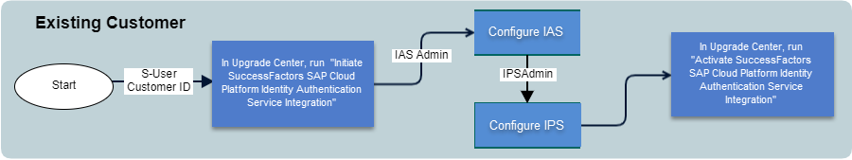
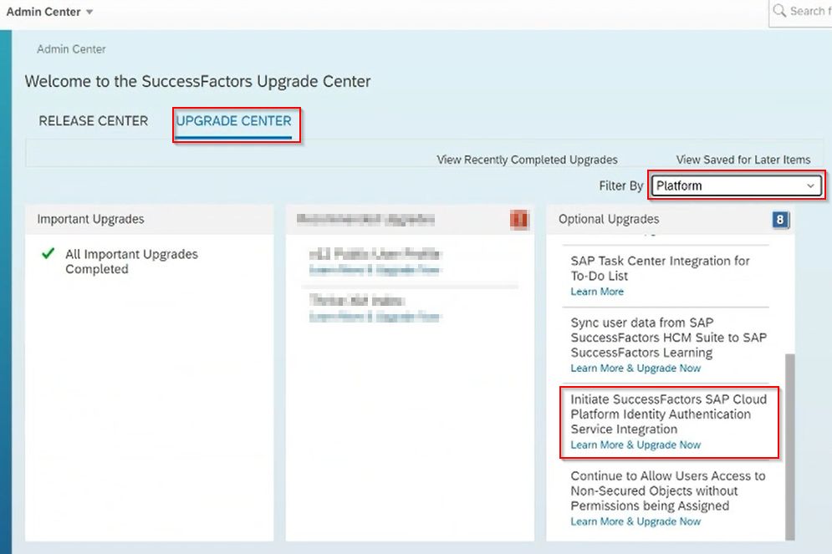

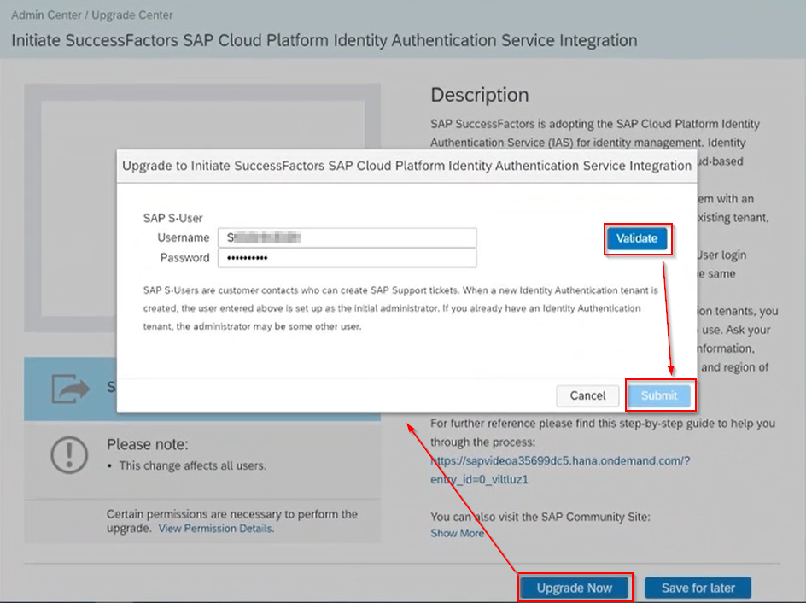
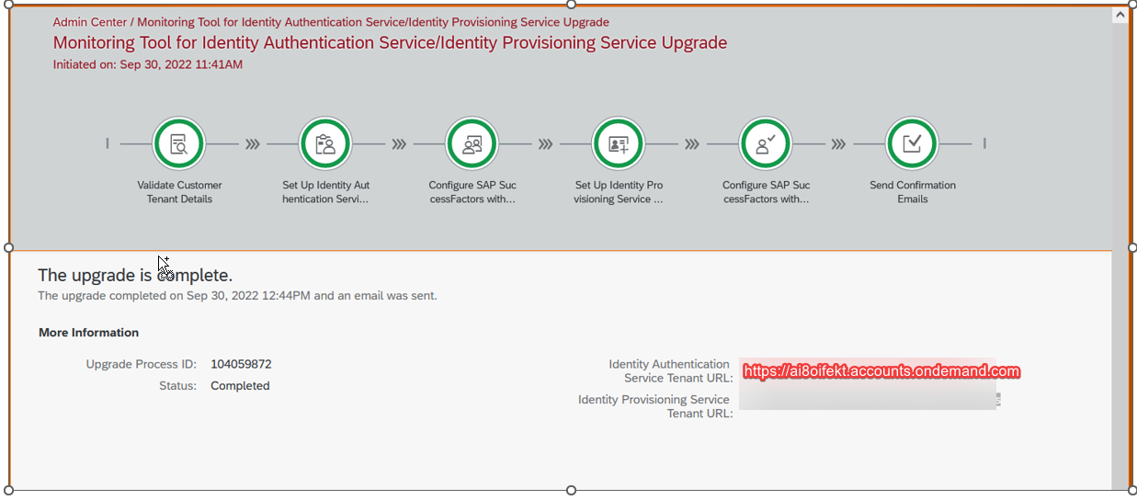
Identity Authentication Service Tenant URL
IAS ADMIN Environment URLS
Non-Prd -
https://ai8oifekt.accounts.ondemand.com/admin/

Step 2. Setup Corporate IDP in IAS
Pre-Req – Perform IPSAdmin Tasks
Set API Exception Login for IPSAdmin (Created automatically when we initiated the IAS process)
The API user created during the upgrade process is called IPSADMIN. This user is intended to become your API user after you've assigned the listed permissions to them. The user that you use to log in to the Identity Provisioning Administration Service has separate credentials.

On SuccessFactors, setup API Exception Login for IPS IP addresses on Password & Login Policy Settings
- In SuccessFactors
  - Admin Center -> Password & Logon Policy Settings
- Click to add an API Login Exception
  - Username: IPSAdmin
  - Maximum Password age: -1
  - Ip Address Restrictions
    - US West (Colorado Springs) us4.hana.ondemand.com 157.133.45.0-157.133.45.255, 130.214.184.64-130.214.184.71, 130.214.183.0-130.214.183.127, 130.214.184.72-130.214.184.79
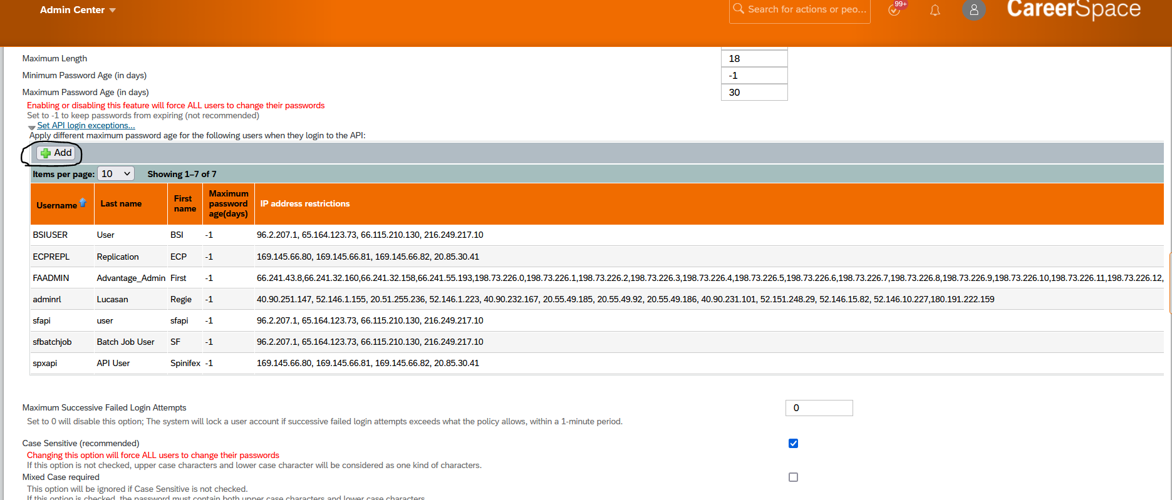
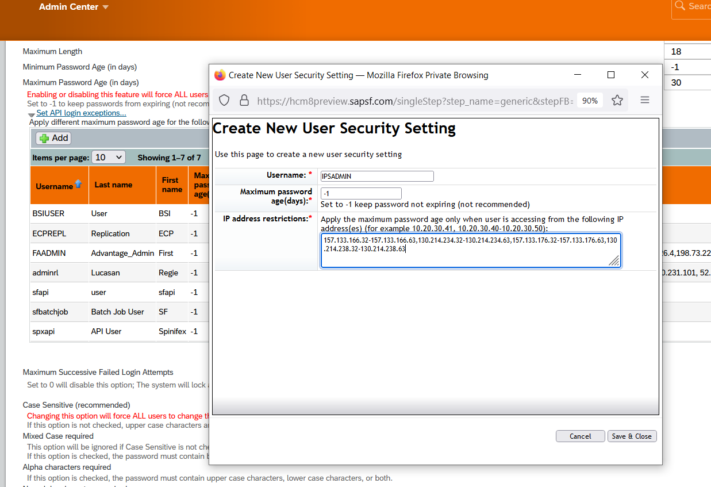
- IP Address Restrictions- This field is used to create an allowlist of IP Address ranges so that Identity Authentication API calls are accepted by SAP SuccessFactors. List of IPS address ranges are in the following link
Setting Up an API User for Sync Jobs in SAP SuccessFactors | SAP Help Portal
- In Test instance the following entry exists:

- 157.133.166.32-157.133.166.63,130.214.234.32-130.214.234.63,157.133.176.32-157.133.176.63,130.214.238.32-130.214.238.63 (Represents IP Address ranges for IAS/ IPS System – Qualifiers are: Region - US/Canada

- Screenshot of Final Configuration (should be similar to the following)
- 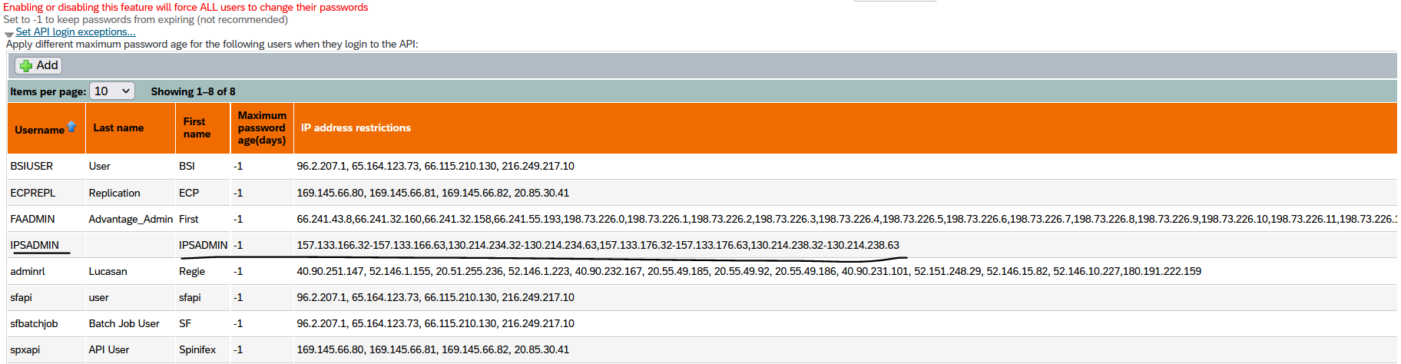

Give IPSAdmin user the permission to sync users
- Admin Center -> Set User Permissions
- Create -> IPSADMIN ROLE
  - Click on Permission
    - Permission 1 – Administrator permission - > Manage Integration Tooles -> Allow Admin to Access OData API through Basis Authentication
    - Permission 2 – Manage User -> Employee Export permission
- Grant IPS permissions to IPS
  - Admin Center -> Set User Permissions -> Manage Permission Roles
  - Create New Permission -> Enter Role name and description
    - Manage Integration Tools
      - Allow Admin to Access OData API
    - Manage User Account
    - Manage User
      - Employee Export
  - Select “Add” option and assign the created role to the IPS Admin Account
- Click on Save Changes

Setting up Corporate SSO integration with IAS
1. Log on to the Identity Authentication Service using the link from your registration email.
2. Go to Applications and Resources.
3. Go to Tenant Settings.
4. Go to SAML 2.0 Configuration.
5. Select Download Metadata File and save the file.
6. Give this file to your corporate identity provider team (Azure IDP) so that they can import this file into your corporate identity provider. This enables a connection to your IAS.
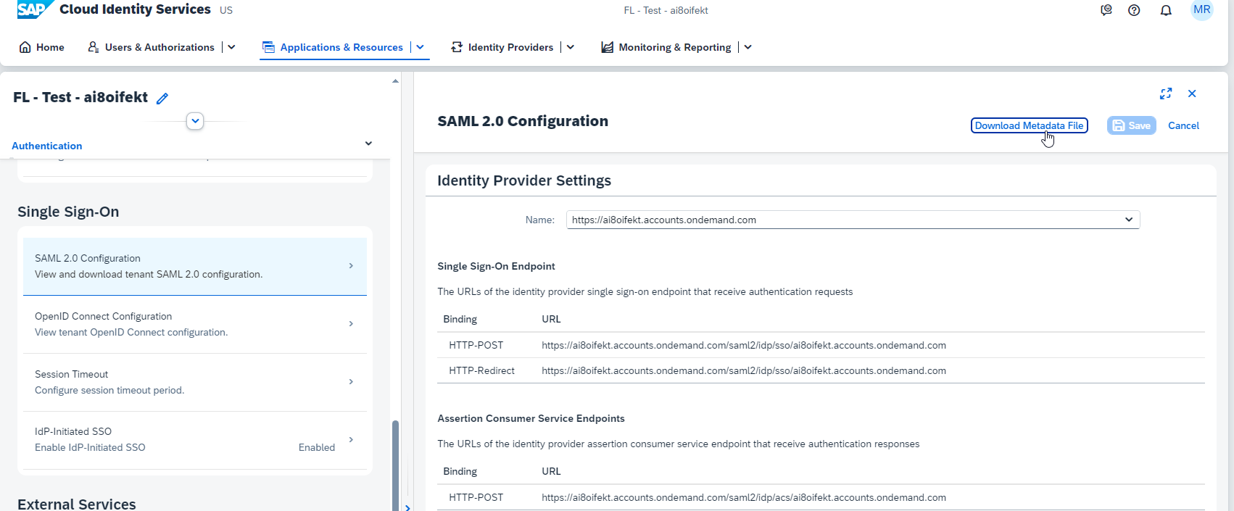

Configure SAP SuccessFactors applications and conditional Authentication
Choose Default Identify Provider for SuccessFactors FLTest Instance to be Footlocker SSO
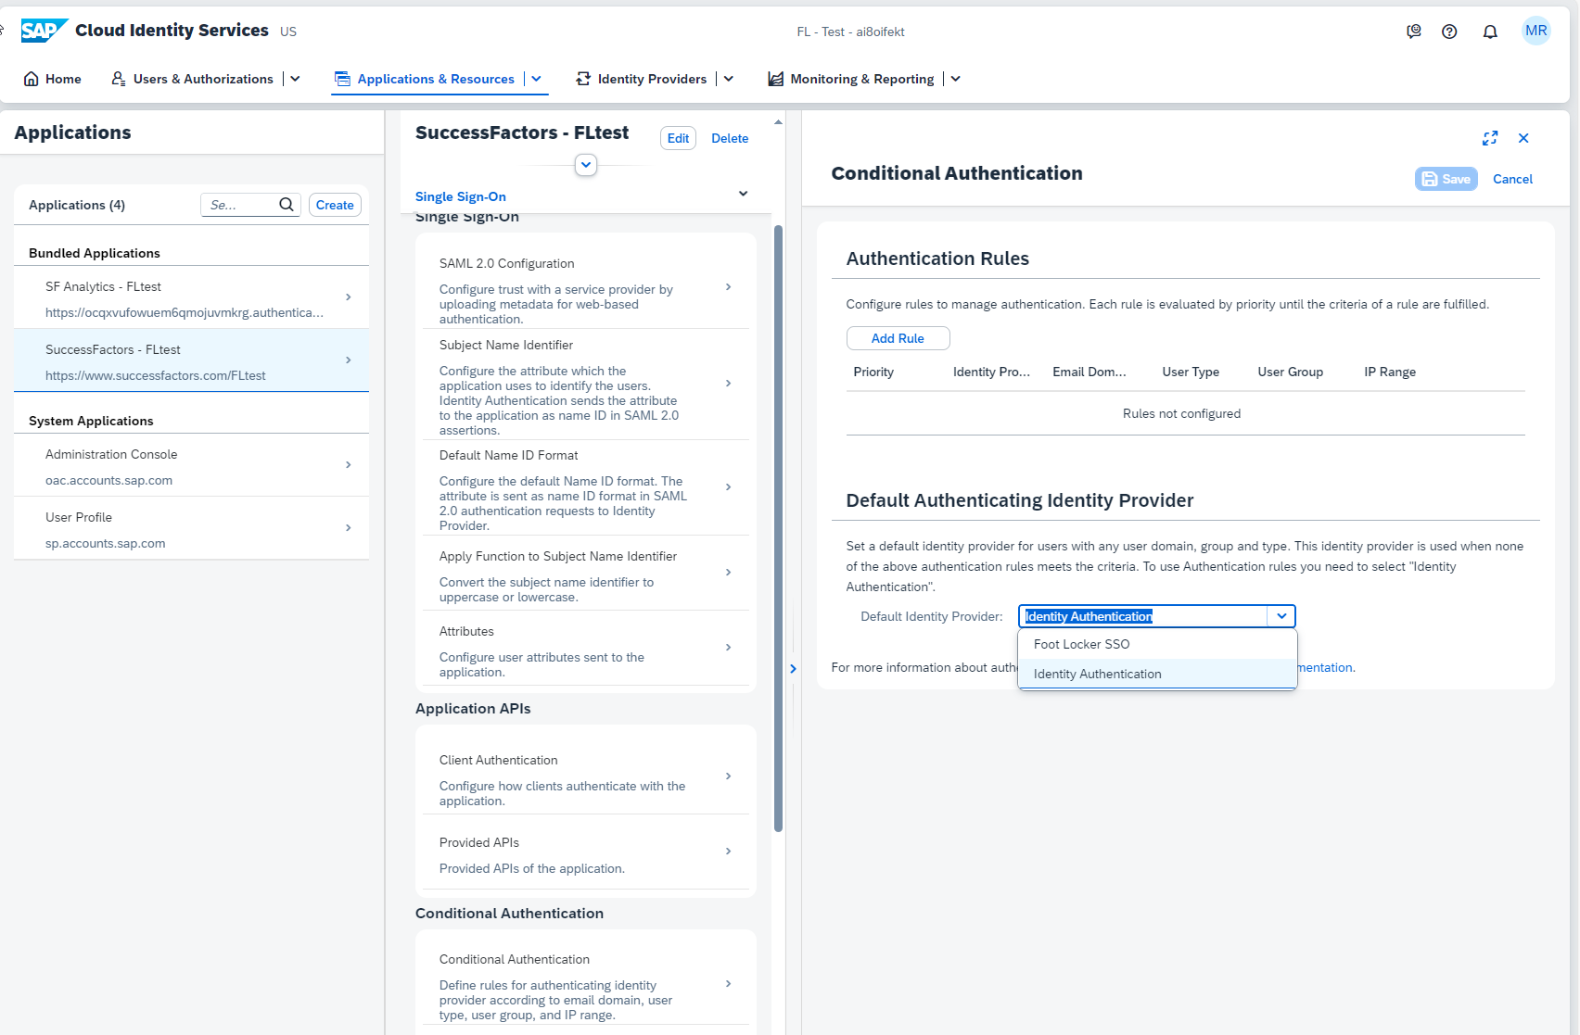

Change Subject Name Identifier to select the Primary Attribute
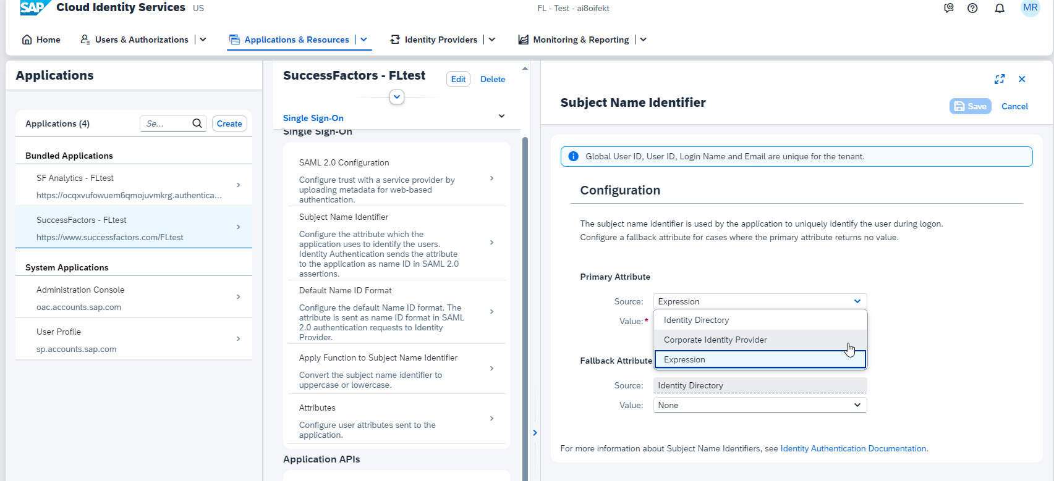

Configure SSO in the Admin Center
- Admin Center -> Tools -> Manage SAML SSO Settings
- Click on Add Assertion Party
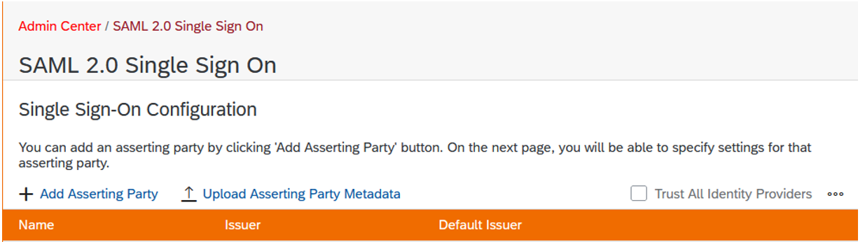
- Download metadata from the previously created Azure IDP fill out the Screen
